**Lab – 21: Enable Azure Multi-Factor Authentication and check the user multi factor auth status.**

**Objective:** The objective of this lab is –

* To enable Azure Multi-Factor Authentication and check the user multi factor auth status.

Enabling Azure MFA by changing user states is the traditional approach for requiring two-step verification. It works for both Azure MFA in the cloud and Azure MFA Server. All the users that you enable have the same experience, which is to perform two-step verification every time they sign in. Enabling a user overrides any conditional access policies that may affect that user. In this lab, we are going to enable Azure Multi-Factor Authentication and check the user status.

**Prerequisite:** EMS Enterprise Mobility + Security E5.

**Steps:**

1. Sign in to your Azure Portal, by using the link - **https://portal.azure.com/**. Enter your credentials and click Sign In.

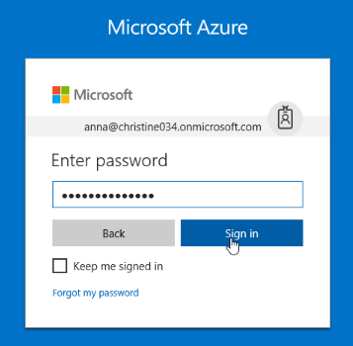

1. Microsoft Azure AD Dashboard will open.

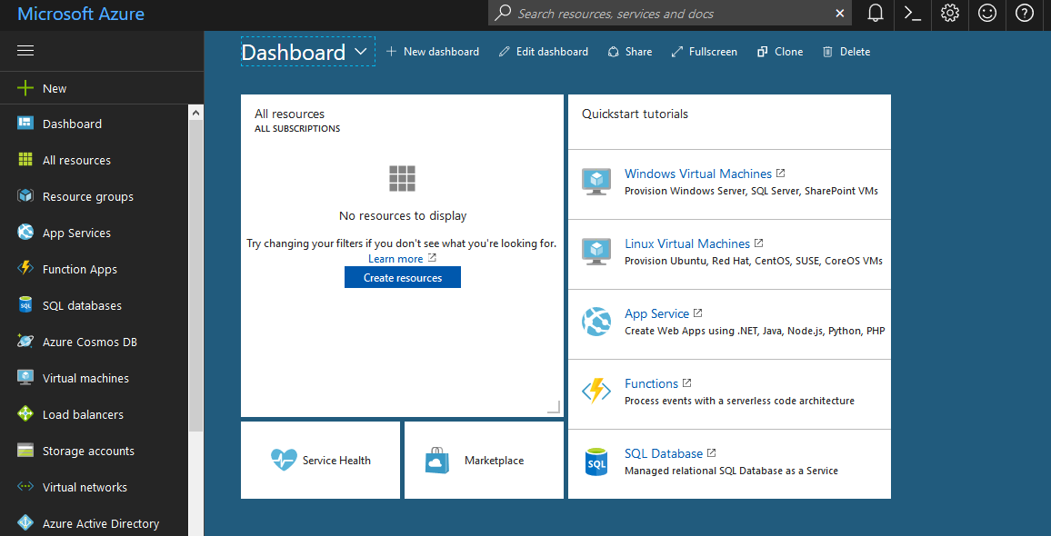

1. Go to **Azure Active Directory** > **Users and groups** > **All users**.

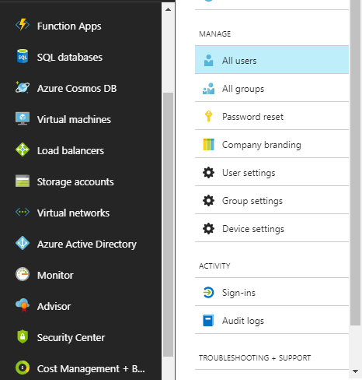

1. Select **Multi-Factor Authentication** from the toolbar.

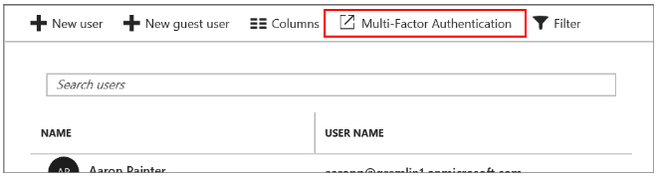

1. A new page, which displays the user states, will open.

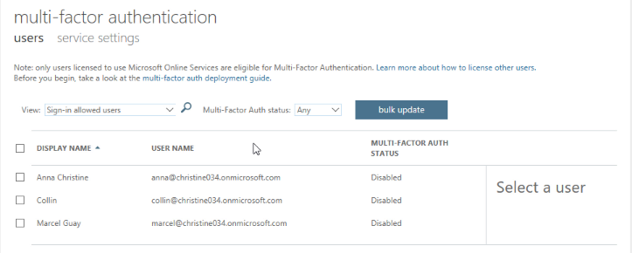

1. Use the preceding steps to get to the multi-factor authentication users page.
2. Find the user that you want to enable for Azure MFA. You may need to change the view at the top. Check the box next to their name.

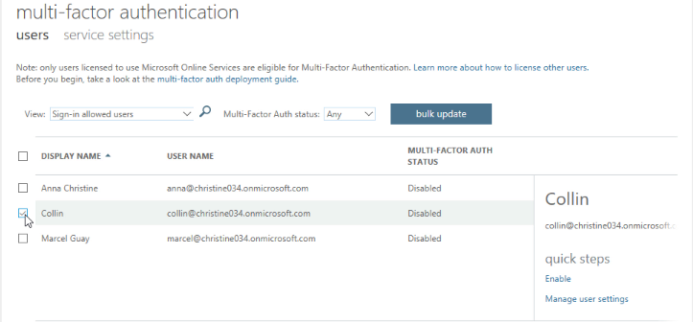

1. On the right, under quick steps, choose **Enable** to enable multi-factor authentication.

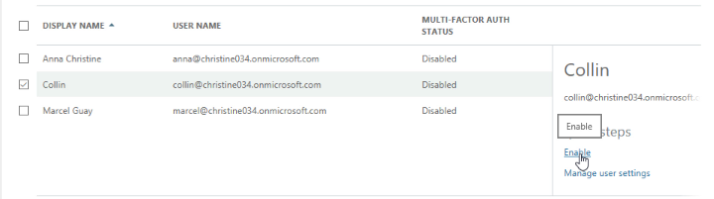

1. Confirm your selection by clicking **enable multi-factor auth** in the pop-up window that opens.

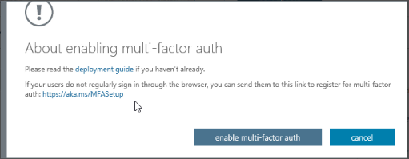

1. Click **Close**, in the updates successful pop-up window.
2. Now, you can see the Multi factor auth status is enabled for that user.

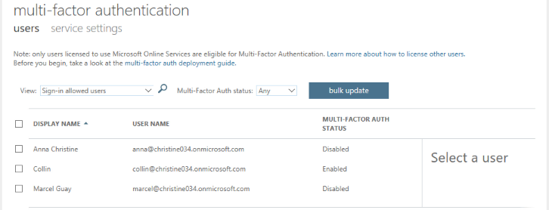

1. So, in this way you can enable Azure Multi-Factor Authentication and check the user multi factor auth status.